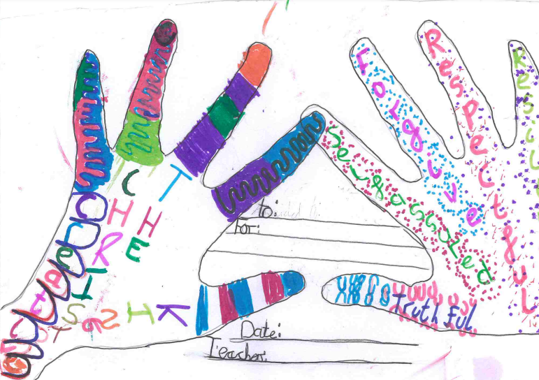
:_________________________________________________________________________________________________________

Signed: Date:

