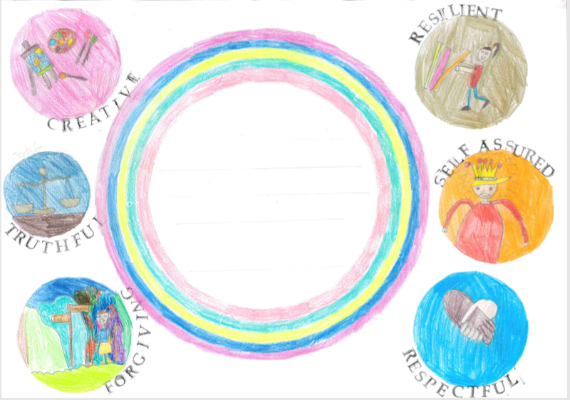
Awarded to
__________________
For:_________________________________________________________________________________________________________

Signed: Date:

