Welcome to our History Page:
We want to teach our children to understand our past so that we can make thoughtful observations and judgements about it. Therefore, we believe that by learning about the footprints of the past, we can better understand the world we live in today and make informed decisions about the footprints we may leave in the future. Central to our approach to teaching history, is a belief that it is far more than a list of dates and events that must be memorised. We use an enquiry-based approach to explore the past and learn about key periods. Within our classrooms, we follow rich lines of enquiry by answering questions such as What is the lasting legacy of the Ancient Greeks? Studying history in this way inspires children’s curiosity, encourages them to ask critical questions and enables them to have a better understanding of the society in which they live and that of the wider world. We aim to help children gain historical perspective by placing their growing knowledge into different contexts, understanding the connections between local, regional, national and international history; and between short- and long-term timescales. Beginning in EYFS children are encouraged to talk about members of their immediate family and community and comment on images of familiar situations in the past. Compare and contrast characters from stories, including figures from the past and show understanding that some places are special to members of their community. Recognise that people have different beliefs and celebrate special times in different ways. In Key Stage 1, our curriculum is mapped to enable children to develop an awareness of the past, using common words and phrases relating to the passing of time. They will start to know where the people and events they study fit within a chronological framework and identify similarities and differences between ways of life in different periods. As they progress through the key stage, they will demonstrate a growing confidence and accuracy when using historical vocabulary, such as monarchy, explorer and artefact. In Key Stage 2, children will continue to develop a chronologically secure knowledge and understanding of British, local and world history, establishing clear narratives within and across the periods they study. This chronology, or sequence of events, will be referred to throughout KS2 so that children become secure in their understanding of important historical events and eras. It will also enable them to begin to identify trends over time and develop the appropriate use of historical terms such as ancient and civilisation.
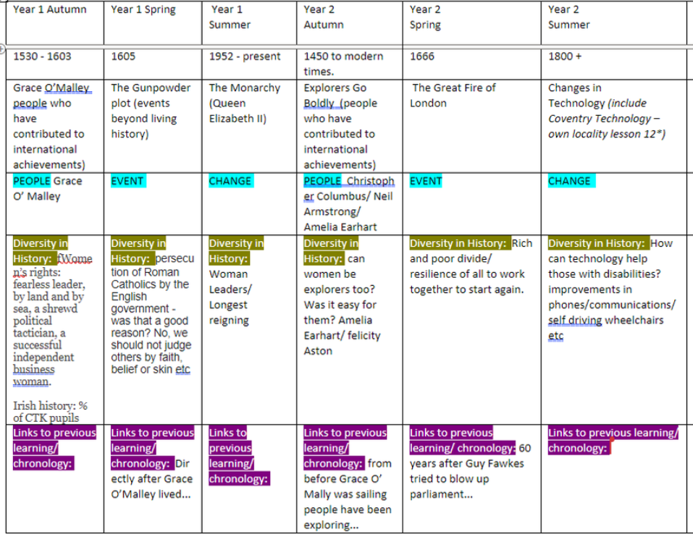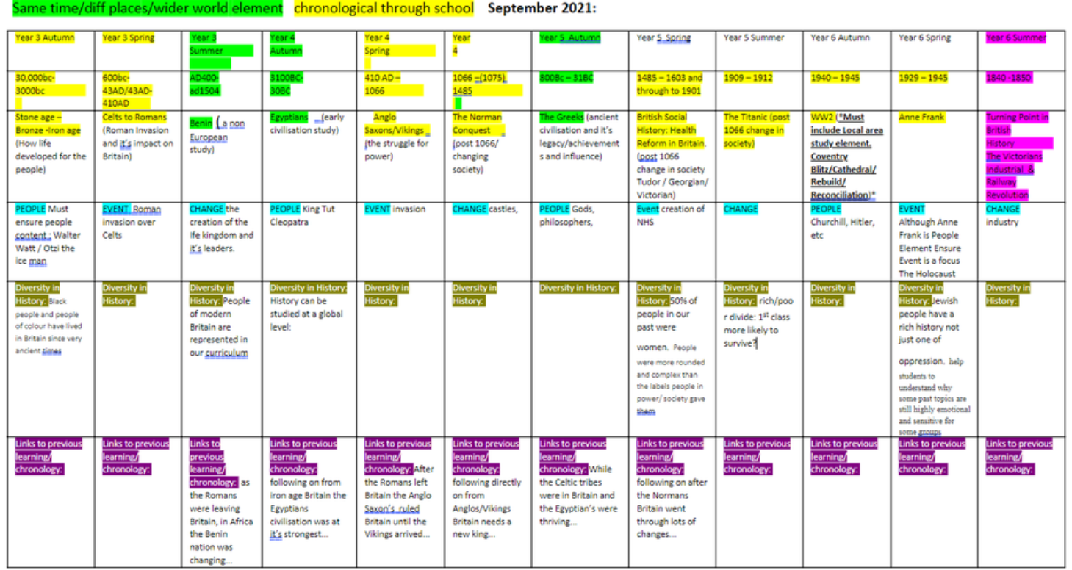
https://www.history.org.uk/student/categories/history-resources-for-students

Great Fire of London
- Told in story form
- Complete package to teach the Great Fire.
- A package designed for teaching the Great Fire with museums

The Tudors
- Full e-CPD unit with teaching ideas and resources provided by the HA
- Article on bringing the Tudors to life in a cross-curricular approach. Although aimed at a secondary audience, primary practitioners may find it useful
- Link to a whole host of classic HA pamphlets on the Tudors.
- Simplified information and quizzes
- A landing page offering links to a host of Tudor games and activities
- Simple information produced on a website by children
- A more wordy site, but interesting information about society and life.
- A more wordy site, but good information about politics, events, customs and life.
- A Key Stage 2 resource package from Royal Armouries
- Background information and resources for teachers provided by Culture24
- Teachers' TV CPD input
- Topic pack of resources to teach Tudors
- The Tudors using ICT from Teachers' TV

Ancient Greece
- Guide to resources for teaching and learning about Ancient Greece provided by the HA
- Guide to links between Ancient Greece and the Olympics, as provided by the HA
- Factual site - very pupil friendly.
- A kid's diary of what Greece is like today
- A factual site, simplified for children
- Greek myths for children, with frame to write their own.
- A site giving advice and examples of lessons on Ancient Greece that have been rated as outstanding by Ofsted. Some are freely available, other resources are for members of this site only.

Florence Nightingale
- Teaching famous people at KS1 - HA provided
- Pupil Friendly factual information
- Interactive site from the BBC
- Teaching ideas
- Florence Nightingale through drama from Teachers' TV
- The Florence Nightingale Museum. They have artefacts online.

Indus Valley
- Interactive site from the BBC
- Factual site for teachers
- Interactive factual site for children
- Site dedicated to teaching this topic - resources, advice and articles available.
- Resource package for this topic

Aztecs
- Fact/information site for kids
- Simple information for kids
- Information site for adults and kids, with interactive puzzles and music games for kids.
- Teaching resources provided by the British Museum

The Victorians
- Complete e-CPD unit provided by the HA.
- Simplified pupil friendly factual site
- Interactive factual site with links and games from the BBC.
- Factual information - possible to difficult for pupils, but good for planning and research or the topic
- Great interactive site offering pupils the chance to see the "virtual Victorians." They can follow them through their daily life and ask them questions. There are also embedded primary sources such as newspapers that they can read.
- A bit too wordy for pupils, but good for research and planning
- Topic pack of resources to teach the Victorians
- Professional development and examples of Ofsted rated outstanding lessons on the Victorians. Be warned however that for some resources, you need to be a member.

World War II
- Links to great new interactive site by award winning film maker Laurence Rees - WW2History.com. However, you need to be a member of the site to get the full benefit. Reductions are on offer to HA members.
- Teaching emotive subjects - T.E.A.C.H Online and HA resource
- What it was like to be a child in World War II from the BBC
- Factual children friendly site
- Teaching resources and interactive site.
- Children in war Professional development from Teachers' TV
- Teaching ideas and resources
- Topic resource pack to teach the topic

Ancient Egypt
- Simple pupil friendly factual site
- Factual site for children
- Factual site for children
- Primary school site with simple facts designed for children
- Quizzes, crosswords and games based around Ancient Egypt
- Egypt cyberhunt
- List of fun sites for pupils on Ancient Egypt
- Resources offered by the British Museum
- Escape from the mummy's tomb interactive game offered by National Museums Liverpool
- Topic resource pack on Egypt

The Vikings
- Here come the Vikings - HA provided.
- Briefing on the Vikings from the sagas. Competition is now over, but resource still useful.
- Simple child friendly site
- Fun facts about the Vikings
- Factual site with games
- Fun interactive site from the BBC for kids
- Jorvik Viking Centre
- https://www.historic-uk.com/HistoryUK/HistoryofEngland/King-Alfred-the-Cakes/

Toys
- Resource pack provided by museum of childhood and partners.
- A little wordy, but some interesting information for teachers and includes links to pictures and other useful sites
- A brief history of toys to get you started
- Teaching resources
- Topic pack of resources for teaching the topic.

General
- The Historical Association
- Encyclopedia site on a vast number of topics
- BBC History
- BBC History learning site
- This site gives links to lots of other sites on curriculum topics
- Link to free resources
- More for secondary schools, but activities and information on crossover topics may be of use.
- Decent coverage of primary topics
- The History Faculty - Some podasts available. This may be of more use to secondary schools, but may be good for subject knowledge
- Good on Tudors and Victorians and provides other weblinks

Christ the King Catholic Primary School
Intent, Implementation and Impact Statement:
History

EYFS National Expectations
Understanding the World (Past and Present)
Talk about the lives of the people around them and their roles in society.
Know some similarities and differences between things in the past and now, drawing on their experiences and what has been read about in class.
Understand the past through settings, characters and events encountered in books read in class and storytelling.

KS1 National Expectations
Pupils should be taught about:
• Changes within living memory. Where appropriate, these should be used to reveal aspects of change in national life;
• Events beyond living memory that are significant nationally or globally [for example the Great Fire of London, the first aeroplane flight or events commemorated through festivals or anniversaries];
• The lives of significant individuals in the past who have contributed to national and international achievements. Some should be used to compare aspects of life in different periods [for example Elizabeth I and Queen Victoria, Christopher Columbus and Neil Armstrong, William Caxton and Tim Berners-Lee, Pieter Bruegel the Elder and LS Lowry, Rosa Parks and Emily Davison, Mary Seacole and/or Florence Nightingale and Edith Cavell];
• Significant historical events, people and places in their own locality

KS2 National Expectations
Pupils should be taught about:
• changes in Britain from the Stone Age to the Iron Age;
• the Roman Empire and its impact on Britain; • Britain’s settlement by Anglo-Saxons and Scots;
• the Viking and Anglo-Saxon struggle for the Kingdom of England to the time of Edward the Confessor;
• a local history study;
• a study of an aspect or theme in British history that extends pupils’ chronological knowledge beyond 1066;
• the achievements of the earliest civilizations – an overview of where and when the first civilizations appeared and a depth study of one of the following: Ancient Sumer; The Indus Valley; Ancient Egypt; The Shang Dynasty of Ancient China;
• Ancient Greece – a study of Greek life and achievements and their influence on the western world;
• a non-European society that provides contrasts with British history – one study chosen from: early Islamic civilization, including a study of Baghdad c. AD 900; Mayan civilization c. AD 900; Benin (West Africa) c. AD 900-1300.

Intent
At Christ the King, we offer a coherently planned sequence of lessons to help teachers and pupils ensure they have progressively covered the skills and concepts required in the National Curriculum. We aim to develop historical skills and concepts which are transferable to whatever period of history is being studied and will equip children for future learning. These key historical skills and concepts, which are revisited throughout different units, are: Historical Interpretations; Historical Investigations; Chronological Understanding; Knowledge and Understanding of Events, People and Changes in the Past; Presenting, Organising and Communicating. The coverage of history in KS1 enables children to acquire an understanding of time, events and people in their memory and their parents’ and grandparents’ memories. The intent in lower KS2 is that children can work in chronological order from ancient history such as ‘Stone Age’ and then progress onto more modern history such as ‘The Victorians. Upper KS2 allows children to repeat and embed this sequence of chronology with a wider selection of ancient history such as ‘The Greeks ‘ through to more modern history such as ‘World War II’. The repeat in KS2 of chronological order from ancient to modern allows for children to truly develop and embed a sense of time and how civilizations were interconnected. Children start to understand how some historical events occurred concurrently in different locations, e.g. Ancient Egypt and the Stone Age.

Implementation
In order for children to know more and remember more in each area of history studied, there is a structure to the lesson sequence whereby prior learning is always considered and opportunities for revision of facts and historical understanding are built into lessons. However, this is not to say that this structure should be followed rigidly: it allows for this revision to become part of good practice and ultimately helps build a depth to children’s historical understanding. Through revisiting and consolidating skills, our lesson plans and resources help children build on prior knowledge alongside introducing new skills and challenge. The revision and introduction of key vocabulary is built into each lesson and can be added to the KWL topic pages for reference. This vocabulary is then included in display materials and additional resources to ensure that children are allowed opportunities to repeat and revise this knowledge. Through these lessons, we intend to inspire pupils and practitioners to develop a love of history and see how it has shaped the world they live in. Our lessons come with end of unit assessments to give the teacher and adults leading History confidence in the progression of skills and knowledge and that outcomes have been met. Topic pages allow pupils to consider what questions they would like answered during the topic, KWL topic pages as well as a reflection at the end of topic.
All History books in KS2 contain an overview timeline which the children can access to see where the period of History fits in to prior learning and encourage children to draw links in concurrent events.
In EYFS children are given the opportunity to explore and learn about different historical events or periods of time. They use a variety of media to show their learning.

Impact
The impact of using the full range of resources, including display materials, will be seen across the school with an increase in the profile of history. The learning environment across the school will be more consistent with historical technical vocabulary displayed, spoken and used by all learners. Whole-school and parental engagement will be improved through the use of history-specific home learning tasks and opportunities suggested in lessons and overviews for wider learning. We want to ensure that history is loved by teachers and pupils across school, therefore encouraging them to want to continue building on this wealth of historical knowledge and understanding, now and in the future. Impact can also be measured through key questioning skills built into lessons, child-led assessment such as success criteria grids, jigsaw targets, KWL grids and summative assessments aimed at targeting next steps in learning.

