

Climate Action Plan
Christ the King Catholic School, Part of the Holy Cross MAC

1 year plan Autumn 2025 – Autumn 2026

Sarah.mills@letsgozero.org
Carbon baseline: 403.61 tCo2e Per pupil : 0.883 tCO2e Calculation: Date 2023-2024 (April)

GET STARTED
ACTION | TIMEFRAME | STAKEHOLDERS | NOTES | TRACKER
Sign up to the Let’s Go Zero campaign  By joining this campaign, your school confirms that it is taking action now to reduce its own carbon impact, and that it demands the UK Government help all schools reach this goal by the end of the decade. | Start: Sept 2024  Review: | Sustainability Lead  MAC Sustainability Lead | Signed up and regular meetings with Sarah (LGZ). | Completed
Calculate your school’s carbon footprint using Count Your Carbon  This free digital tool allows you to calculate the carbon footprint for your educational setting . You will need to collect data on energy use, water, waste, purchasing, meals, daily commutes and school trips in order to get your carbon baseline score which can then be used to track progress. | Started April 2025  Review: November 2025 | Sustainability Lead  MAC Sustainability Lead | Look at your CYC score to see which areas are causing most of your emissions.  Recalculate after a year to measure progress.  Will complete data for 2024-2025 in Autumn Term. | Completed

School Sustainability Stakeholders:
Sustainability Lead:  Donna Nicol | Head:  Jennifer Riach | School Business Manager:  Kate Morgan | Site Manager:  Adam Willetts | Catering Manager & Company:  ABM | Sustainability Governor/PTA contact:  Mark Farr
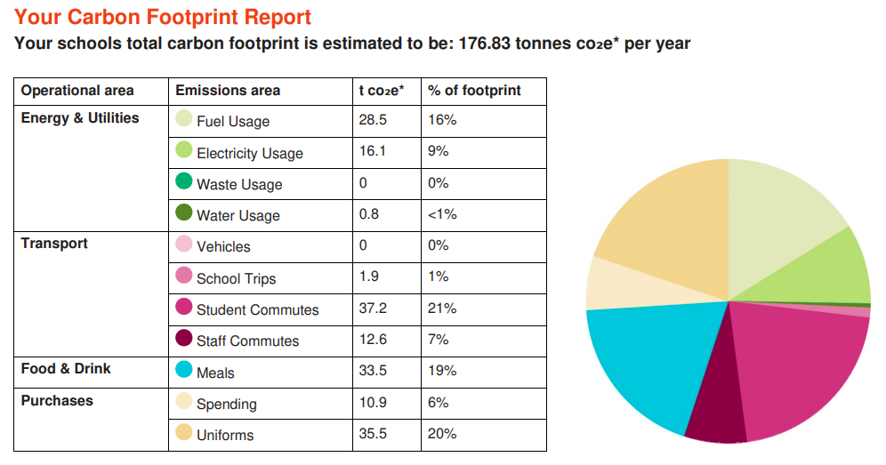

- Decarbonisation and Energy Efficiency (WASTE REDUCTION)
Calculating and taking actions to reduce carbon emissions and becoming more energy efficient
ENERGY – BEHAVIOUR CHANGE
ACTION | TIMEFRAME | STAKEHOLDERS | NOTES | TRACKER
Take part in a switch off campaign (free)  Switch-Off Fortnight 2025 (Nov). ~10% energy saved by participating schools. | Start: Autumn  Review: | Sustainability Leads. | Switch off Campaign for Autumn Term.  MAC led programme for 2024-2025, come back to in Autumn 2025. | In progress
Monitor energy use on a regular basis through platforms such as Energy Sparks or Zenergi  Up to 60% of the energy consumed at a typical school is when there are no students in the building. Access energy management platform e.g. Energy Sparks or Zenergi to visualise energy usage and share that with pupils and staff to identify where energy is wasted and encourage energy saving behaviour. | Start: September 2025  Review: | Sustainability Leads. | Stark Energy – for monitoring energy. Training for staff to use.  Energy Sparks – Could we sign up and use? Educational Tool. Resources are free. | In progress
Incentivize students to address energy usage e.g.  Appoint energy monitors in each class to carry out spot checks on lights/appliances left on, classroom temps, school thermostat settings following these suggestions: energy monitors activities | Energy Sparks | Start:  Review: | Sustainability Leads. | Energy Monitors – track each lunchtime. Eco Group.  Lightbulb Award – Every Friday.  Use Energy Sparks. | In progress/
Set your BMS/BEMS appropriately in the evenings, weekends and school holidays, when the building may be out of use.  Ensure BMS/BEMS has efficient timings and temperatures set for the school day e.g. 6am-1pm at 18 degrees in classrooms and off evenings/weekends. Check hot water system has efficient timings and temperature set. | Start:  Review: | Site manager | Talk to SSO’s to check energy in off or on at the correct times.  Professional company evaluating in September 2023. Use SSO during Switch off Fortnight. | In progress
TRANSPORT
ACTION | TIMEFRAME | STAKEHOLDERS | NOTES | TRACKER
  Run Active Travel campaigns  Participate in one or more Active Travel Weeks:  - Sustrans Big Walk and Wheel 2025 UK’s biggest walking, wheeling, scooting and cycling to school challenge March-April. Free  - Cycle to School Week - Bikeability October. Schools receive an activity pack and chance to enter a prize draw. | Start:  Review: | Sustainability Lead | Completed Living Streets Campaign in 2024-2025.  Look at half termly events with themed walk, cycle or scoot to school. Track data.,  Walk to school week – May 18th – May 22nd  Cycle to School Week – 13th -17th October | In progress
Provide bicycle proficiency lessons for students  Bikeability programme is available through wcccycletraining@warwickshire.gov.uk. | Start:  Review: | Sustainability Lead | Bikeability for Year 5 book for Autumn Term | In progress

PROCUREMENT
ACTION | TIMEFRAME | STAKEHOLDERS | NOTES | TRACKER
Reuse your school uniform through a Uniform Exchange Maximise reuse of school uniform through a pop-up Uniform Exchange | Start: September 2025  Review: | Tina  Sustainability Lead | Uniform – Second Hand Shop. Track your savings on the Uniform. Tally chart to track this. (Ask Tina).  Get PTA involved in and pop-up at events such a new information evening in September. | In progress
Establish procedures for the reuse of school supplies Establish procedures for the reuse of school supplies either within school or through sites such as School Resources Exchange and Collecteco (furniture) | Start: September 2025  Review: | Sustainability Lead | Collecteco – BAM. Work with MAC. Furniture refer to Martyn. Bigger scale.  Use School Resource Exchange and see if there are any thing we can exchange. | Not started in school, started at MAC headoffice
Include sustainability as part of procurement criteria e.g. recycled, non-toxic, ethically sourced. Start with paper sourcing and reducing use – buy recycled/sustainably sourced paper and single dispense paper towels/toilet paper. | Start: September 2025  Review: | Sustainability Lead | Papercup – track how much people are using.  Can we send Papercup to individual staff.  Paper towels – changing to new cleaning contract. Pull one at a time. Better quality towels. Millwoods – contact them. | Not started

FOOD
ACTION | TIMEFRAME | STAKEHOLDERS | NOTES | TRACKER
Meet with catering team (new) to discuss sustainability and sustainable changes. Look at food waste, plate waste, choices and planet friendly day.  If every child switched one meal from animal to a plant-based once a week that could save the typical primary school (300 students) over 20 tCO2e in an academic year! | Start: September 2025  Review: |  | .  Donna to meet with Catering Team and discuss next steps and ideas | Not started/  In progress/  Completed

WASTE
ACTION | TIMEFRAME | STAKEHOLDERS | NOTES | TRACKER
Education around recycling as part of assemblies or other whole school opportunities  Deliver assembly/ information to students regarding what is to be put in each bin. Young Climate Warriors provide slides/ assemblies.  Do a waste audit and encourage students to take part in the whole process. Wastebusters have a helpful step-by-step guide for this. | Start:  Review: |  | Complete assembly on Food Waste.  Calculate food waste with new catering team and look at food waste versus plate waste, | In progress
Start / improve composting and food waste facilities Ensure compliance with new food waste & dry recycling collection policy as of April 2025 (separate collection, bins, assembly, announcements etc.) .  WRAP - Business of Recycling – Guide  Getting your school or trust ready for new recycling regulations | Start:  Review: |  | Energy Sparks – Free tool to calculate what you are throwing away.  Look at solutions to bins on the playground and classrooms/staffrooms  Fully compliant – waiting for food waste to be collected. | In progress

- Climate Education, Green Skills and Green Careers
Ensuring the education you provide gives knowledge-rich and comprehensive teaching about climate change, and that your teaching staff feel supporte d to offer this
CULTURE
ACTION | TIMEFRAME | STAKEHOLDERS | NOTES | TRACKER
Set up an eco-club for pupils to take leadership on issues and educate/engage the school community  Work towards Eco Schools Green Flag status and incorporate action areas within school climate action plan. | Start:  Review: |  | Sustainability groups. | Completed
Share best practice and ideas internally. Sign up for Free Assemblies/workshops. Aim for one per half term/term  e.g Severn Trent Education (water/sewage, in person)  Young Climate Warriors (primary only, in person)  Better Planet Education (large range of virtual options)  Proveg (virtual re planet-friendly menu) contact Martin.skingley@proveg.org | Start:  Review: |  | Severn Trent Bus Visit, assembly and workshops booked, | Not started/  In progress/
Apply for funding for eco projects  - Ask families whether any of their workplaces offer applicable grants  - Finding funding | Education Nature Park  - Severn Trent Community Fund up to £20K  - npower up to £20K (use link) within 50 miles of Solihull  - Tesco Stronger Starts: Apply for a grant – up to £1,500  - Bag2school textile fundraiser  - Apply | Aviva Community Fund – matching funds  - Shops and service stations e.g. Moto, One Stop, Morrisons,  - Waste and utility providers e.g. Veolia, Biffa, WME, National Gas | Start:  Review: |  | Cardinal Newman can get funding for Education Nature Parks.  Granted £500 funding from Tesco.  RagBag – used last year and raised £200 for school to use in garden.  Barclays and JLR have offered volunteer days. Barclays also gave a grant of £500. | Completed
Set up a sustainability working group to collaborate and effect change including a sustainability governor, SLT, site manager, teachers, and PTA. Ensure one person has oversight, taking the title of ‘Sustainability Lead’. Connect with fellow Sust Leads from other Trust schools to share best practice. | Start:  Review: |  | Sustainability Lead to meet with Headteachers, Sustainability Lead, SSOs and Central Team to look at making working groups to bring about change.,  Dates booked in for 2025-2026  Met with Julie Rowaldson and Paul Edmmond, joined UKSSN, attending conference in Birmingham. Joining joins and meetings for sustainability leads online, | In progress
CURRICULUM, GREEN SKILLS AND CAREERS
ACTION | TIMEFRAME | STAKEHOLDERS | NOTES | TRACKER
Complete a curriculum audit and increase sustainability content in curriculum  Map existing curriculum connections to using Map the curriculum tool - The Education and Training Foundation.  - Watch LGZ Webinar recording Embedding Sustainability into the primary curriculum  - Consider Teach the Future’s Curriculum for a Changing Climate guides highlighting potential climate connections to NC  - Use Learning through Landscapes free lesson plans for curriculum based and Forest School learning.  Include green skills as Unlocking green skills and careers: A teacher guide | Energising Futures | Start: September  Review:  : |  | Staff meeting – what are we already doing?  Allocating time for this.  Learning through landscapes. Good resources and lessons. | In progress
Access the DfE’s Climate Ambassadors scheme  Place a request for free support with climate action. Regional Hub Managers will assist you in finding the right specialist volunteer in your area. Please get in touch via email: climate-ambassadors.wm@keele.ac.uk | Start:  Review: |  | Contact Ambassador Scheme and see about support and what they can offer. | In progress
- Biodiversity and Green Infrastructure
Creating habitats and adopting practices that will enhance species diversity on the school estate and beyond
NATURE
ACTION | TIMEFRAME | STAKEHOLDERS | NOTES | TRACKER
Enrol with the NENP  Register school grounds and follow five-part Education Nature Park plan from DfE, auditing and encouraging biodiversity. | Start: September 2025  Review: Termly | Eco Coordinator/ Forest School lead | Education Nature Park – 5 Step Programme.  DN to start taking groups to complete on a Wednesday PM. DN to work with schools across the MAC to get started on Education Nature Parks. | Not started/  In progress/  Completed
Have pupils carry out wildlife surveys  Conduct wildlife surveys and habitat mapping using the Nature Park resources or take part in activities such as the Big Birdwatch with the RSPB. | Start:  Review: | Sustainability Lead | RSBP – Birdwatch –7th January 2026 | In progress

- Climate adaptation and resilience
Taking actions to reduce the risk of flooding and overheating and to future-proof scarce resources for potential shortages
ADAPTATION AND RESILIENCE
ACTION | TIMEFRAME | STAKEHOLDERS | NOTES | TRACKER
Write a heatwave policy that addresses areas such as school dress code, passive ventilation measures, PE lessons and slip slap slop campaigns  Consider adopting the joint union heatwave protocol including short term, medium term and long term measures. | Start: September  Review: |  | Protocol for the hot weather. Student led activities  Martyn (CSEL) to look into policy for the coming year. | In progress
Conduct a grounds audit The Climate Ready School Grounds survey from Learning Through Landscapes covers all weather conditions and involves students' opinions of their grounds. | Start: September  Review: |  | To discuss and sort with Martyn (CSEL) and develop over the coming year. | In progress

WATER
ACTION | TIMEFRAME | STAKEHOLDERS | NOTES | TRACKER
Arrange for a water audit from your local water provider Register for a free water audit from Severn Trent (available from April ’25 through Green Recovery funds). Schools can save up to 18% and receive water saving kit as needed. | Start:  Review: |  | Lee has done this for all schools who are now being contacted to arrange dates.  Register for free water audit for Severn Trent. Council have done. Moved to Wave, | In progress
Raise awareness around water consumption and efficiency through workshops and assemblies  Make the most of free assemblies to engage and inform the school community Severn Trent Education. | Start:  Review: |  | Use Water Wise Resources,  Link to Lent and Walk with Water.  MAC event to raise awareness of water use. | In progress
Attend Water Literacy Training and looks at water literacy resources |  |  | DN to attend Water Literacy Training and look at water literacy resources for MAC event.


