

School Travel Action Plan

Christ the King Catholic Primary School

Address: | Scots Lane, Coundon, Coventry, CV6 2DJ.
DfES Number: | 331/2001
Head Teacher: | Miss Jennifer Riach

Version | Date Approved | Date of Next Review

Purpose of the Travel Plan
The purpose of this School Travel Plan is to promote safe, sustainable, and healthy travel to and from Christ the King Catholic Primary School. By encouraging walking, cycling, and other environmentally friendly modes of transport, we aim to:
- To increase awareness among pupils, parents and staff about the health, environmental and social consequences of their travel choices.
- To reduce traffic congestion around the school gates.
- Increase the number of children walking and/or cycling to school.
- To improve safety on the journey to school by reducing car use.
- To increase the number of pupils participating in road safety education.
- To review the School Travel Plan on a regular basis.

School Location and Access
Location of school | Scots Lane, Coundon, Coventry and Westhill Road, Coundon, Coventry.
Catchment area | Please note that the catchment area of Christ the King Catholic Primary School is a specific area located within Christ the King and Our Lady of Lourdes parish and not the whole parish.
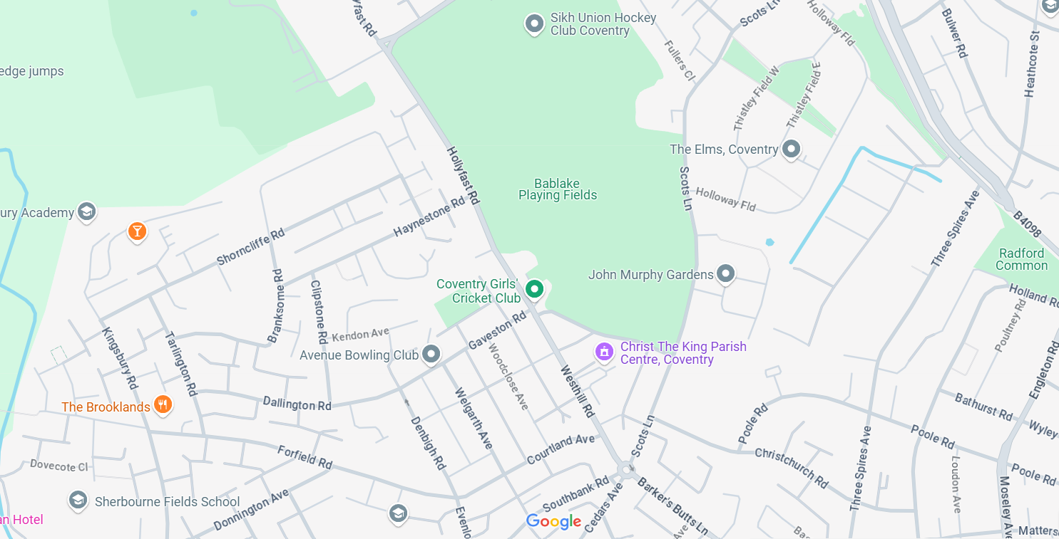
Site access(es) for vehicles and pedestrians | Westhill Road site via the church carpark and Holyfast Road, access to the back of Nursery  Scots Lane site and Duncroft, access to the playing fields.
School safety zone | Westhill Road and Scots Lane site

The school
School type | Catholic Primary School with Nursery Provision
School age range | Aged 3-11
Pupils on roll (date) | 451
No. pupils outside catchment area | ???
School start and finish time | Core hours: 8:50-3:30  8:40-3:15  Extended hours for wraparound breakfast clubs and after school: 7:45-18:00
Number of staff | 46 Staff Members including teachers, support staff, cleaners, SSO, Admin etc.
On-site parking spaces for staff and visitors (include parking provision for nursery staff if provided jointly)  Tw
  Scots Lane | Westhill Road
  Staff: 12 spaces | Staff: access to church carpark - over 30 spaces available
  Visitors: 0 spaces | Visitors: access to church carpark - over 30 spaces available
  Disabled: 1 space | Disabled: access to church carpark - 3 spaces
  Car Share: 12 spaces | Car Share: access to church carpark - over 30 spaces available
Typical number of staff/visitors who must park on the public highway each day | No staff at Westhill Road site  Between 5 – 10 staff members at Scots Lane site
Bicycle/scooter parking spaces | Staff: storage on school site – up to 10 bicycles spaces  Pupils: use of car park spaces
Any other relevant information | No provision of a shower or electric charging points. Changing facilities available on school via staff toilets.

Travel issues relating to the school
Details of public transport links, including distance of bus/tram/rail stops to school and frequency of services | Bus stop close to Westhill Road school site. Direct link into Coventry City Centre and main Bus station.
Local cycle infrastructure | Cycle lane has been installed by Coventry City Council from outside Westhill Road school, along Barker Butts and into Coventry City Centre.  City bikes
Details of travel survey data for staff members and pupils. Data Autumn 2024.
   | Staff | Students
  Car | 55 - 87% | 282 – 62%
  Walk | 8 - 13% | 107 – 23%
  Bus | 0 | 1 – 1%
  Taxi | 0 | 5 – 1%
  Cycle | 0 | 12 – 3%
  Scoot | 0 | 25 – 5%
  Park and Stride | 0 | 25 – 5%
  Total | 63 – 100% | 457 – 100%
Known travel to school issues (e.g. where do parents park/are zig-zag lines ignored/do parents park across residents’ driveways/is there a lack of off-street parking locally making parking difficult) | Parents parking on yellow zig zag lines outside of school at both Westhill Road and Scots Lane site.  Parents Park across residents’ driveways.  Lack of street parking at Westhill Road site.
Reason for development of School Travel Action Plan (include details of planning permission which requires School Travel Action Plan, such as details of the development itself, expected opening date, expected pupil capacity increase, any increase in staff numbers) | Sustainability focus on the school environment or wider global issues around pollution.
Areas for concern expressed during the planning process, either by planning and highways officers, or by members of the public | N/A

School Travel Plan Actions
to improve pupils’ safety through Road Safety Education (RSE), encourage safe and considerate parent driver behaviour with sustainability, health and environmental considerations in mind

Objective: To create a school environment where pupils and parents feel safe
To encourage less use of cars/vans on the school run
To encourage safe and considerate parent driver behaviour
To educate parents on safe and considerate parking behaviour
Priority | How will we achieve this?
1) Reduce pollution and congestion issues at school travel time | Continue to stagger gate opening and timings for the start and end of the school day to significantly reduce traffic problems.
2) Monitor and measure our impact as school on the way we travel to and from school. | Complete a hands up survey yearly to measure the impact of the School Travel Plan.
3) Increase intake of Bikeability Course | Promote cycling and cycling safely at school and encourage those less reluctant to take part in the Bikeability course in Year 5.  Take part in National Cycle to School Week  Improve parent confidence and knowledge of the scheme.
4) Increase the number of children walking or park and striding to school. | Use the ‘Living Streets’ Wow Walk to School Campaign.  Complete data on a weekly basis on how children travel to school.  Reward children to monthly badges.  Encourage a long-term behaviour change
5) Encourage children to walk between sites. | Continue to use the ‘Walking Bus’ to move from one site to another. Including before and after school club, assemblies, mass etc.  Encourage staff to walk between sites when moving from one place to another for a meeting.
6) Promote and encourage staff to have less impact | Promote the cycle to work scheme  Promote car sharing  Promote walking to school where possible, offer incentives to staff who make a real effort.
7)Share the School Travel Plan | Make sure staff, governors and parents understand the School Travel Plan.
8) Promote considerate and environmentally friendly behaviour | Zig-Zag Ban outside school gates, use cones to reinforce this. Regular reminders in School Newsletter.  Promote “Park and Stride” schemes from willing locations (pubs, community centres, supermarkets)  New Parent Pack to offer parental guidance on school policy or requirements on dropping off/parking near school  - Pupils’ Messages – Pupils to develop messages aimed at parents, with pupil safety, consideration towards residents and environmental considerations as possible topics

School Travel Plan written by: | Jennifer Riach and Donna Nicol
Date: | 24th January 2025
Approved by:
Date:
Approved by: | [Insert name of LPA officer]
Date:
Next review to be submitted by: | [To be confirmed by LPA]

