Year 1 | WOW DAY SUGGESTIONS  - 1. Royal Party- Design flags/posters, tea party 2. Firework Themed Day – Art, Poetry, Science Rockets, Songs. 3. Pirate Day – Dress as Pirates, Design Pirate Ships, Pirate dances
 | AUTUMN  Cross Curriculum links: Humans/ Animals/ Our Local Area/ The Monarch (Queen Elizabeth) | SPRING  Cross Curriculum links: Everyday Materials/ Our Country / The Gun Powder Plot | SUMMER  Cross Curriculum links: Plants / wonderful Weather / Grace O’Malley
Narrative | 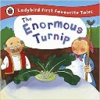  Traditional Tales  The Enormous Turnip- Recount  - Recount the story | 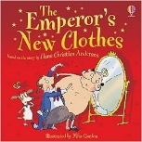  Traditional Tales  The Emperor’s New Clothes- Narrative/Diary  - Diary of character’s reaction to the emperor’s lack of clothes! | 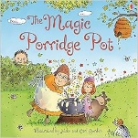  Traditional Tales  The Magic Porridge Pot - Narrative  - Own story based on the original
Narrative |  | Contemporary Fiction  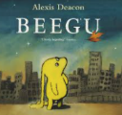  Beegu Alexis Deacon -Letter/character description  (Literacy Shed +)  - Write a letter from Beegu to her parents about time on Earth  - Character Description of Beegu | 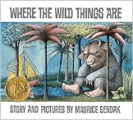  Classic Stories  Where the Wild Things Are Maurice Sendak Character Description/Letter  - Write a description of the wild things  - Write an apology letter (Max to Mum)
Narrative | Contemporary Fiction:  Alan’s big Scary Teeth-Jarvis  (Literacy Shed +)  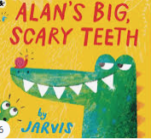  Non- chronological report / Character description – Linked Science  Labels, lists and captions  - Non-chronological report of an animal  - Write labels and captions for animal report  - Character description of Alan the Alligator. | 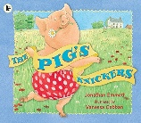  Contemporary Fiction  The Pig’s Knickers Jonathan Emmett Persuasive Writing  - Write a persuasive description to sell a new outfit for the pig | 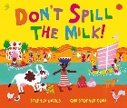  Contemporary Fiction  Don’t Spill the Milk Stephen Davies  - Write a setting description  - Write in role as Penda – ‘My journey’
Non-Narrative |  | Recount –  - Write a simple recount linked to school trip. | Information Texts  - Write a simple leaflet about schools in the past linked to history unit.
Non-Narrative |  | Recount –  - Write a simple recount linked to school trip. | Instructions  - Write instructions about how to build a windmill linked to DT.
Poetry | Classic Poems  What is Pink? Christina Rosetti  - Write a poem about a colour based on the original | Contemporary Poet  Julia Donaldson e.g. Wriggle and Roar  - Write and perform own action rhyme | Forms of Poetry - Acrostic Poems  - Write a simple acrostic poem about the school, an aspect of topic etc.

Year 2 | WOW DAY SUGGESTIONS  - Explorers Day 2. Firefighter Visit – Fire safety Day (posters, art work etc) 3. China Day – Food, music, art etc
 | AUTUMN  Cross Curriculum links: Living Things and Humans / Wonderful World/ Explorers Go Boldly | SPRING  Cross Curriculum links: Uses of Everyday Materials / Magical Mapping & the Seaside / The Great Fire of London | SUMMER  Cross Curriculum links: Plants / China / Changes in Technology
Narrative | 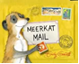  Contemporary Fiction  Meerkat Mail -Emily Gravet (Lit Shed +)  Postcard/non-chronological report  - Write a postcard of daily life from the perspective of a meerkat.  - Write a non-chronological report on meerkats | 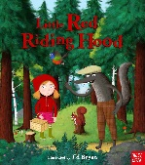  Traditional Tales  Narrative/Information text  Little Red Riding Hood & alternatives e.g., Good Little Wolf  - Write a ‘wanted’ poster for the wolf  - Rewrite the story with alternative /new animal | 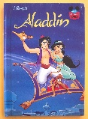  Traditional Tales – Other Cultures  Aladdin  Diary/letter  - Write Aladdin’s diary at different points in the story – trapped in a cave and when rich.
Narrative | 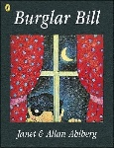  Classic Stories  Burglar Bill Alan Ahlberg – Character description/book review/Story with an alternative ending  - Write a character description of Bill  - Write a story with an alternative ending where Bill steals some other creature e.g., a pet  - Write a film review linked to Into Film Week | Contemporary Fiction  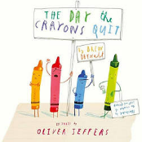  The Day the Crayons Quit – Drew Daywalt  Persuasive letter/Diary entry (Lit Shed +)  - Write a letter as Duncan to either red, grey, green or pink crayon | 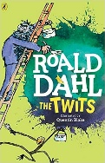  Classic Stories  The Twits Roald Dahl  Narrative  - Write a character description of Mr / Mrs Twit  - Write a newspaper report linked to an event in the story.
Non-Narrative | Non-chronological report  Write a non-chronological report about meerkats. | Information text  - Write an information text based on growing a sunflower (linked to science) | Recount  - Write a recount linked to school trip
Non-Narrative | Letter  - Write a letter to Santa | Recount – diaries  - Write diaries in role as different people during the Great Fire e.g. Samuel Pepys, boy/girl keep? | Instructions  - Linked to DT project
Poetry | Classic Poems  The Owl and the Pussycat Edward Lear  - Write a letter from the owl about the events in the poem | Contemporary Poet  Kit Wright e.g. The Magic Box  - Write their own poem based on The Magic Box | Forms of Poetry - Shape Poems and Calligrams  - Write a selection of poems linked to a theme or topic

Year 3 | WOW DAY SUGGESTIONS  1.Stone Age Day – food, clothes, cave art 2.Rainforest Day – create rainforest canopy, animal art work, create music for the rainforest. 3.Roman Day
 | AUTUMN  Cross Curriculum links: Forces and Magnets / Extreme Earth / Stone Age – Bronze Age | SPRING  Cross Curriculum links: Rocks /Animals including Humans / The Rainforest / Shang Dynasty | SUMMER  Cross Curriculum links: Plants / Light / Surveying the Land / Celts to Romans (Roman Invasion)
Narrative | 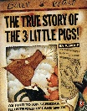 The True Story of the Three Little Pigs Jon Scieszka / Trust Me, Jack’s Beanstalk Stinks Eric Braun  Traditional Tales – Alternative Perspectives  Biography/Narrative  - Write a biography of the Big Bad Wolf – explain what happened in his past to make him go bad.  - Write own alternative perspective tale e.g., True Story of Goldilocks  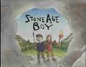 | 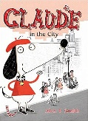  Contemporary Fiction  Claude in the City – Alex T Smith  Narrative  - Write a diary of a day in the life of Claude  - Write new Claude adventure story e.g Claude in the Memorial Park  Biography  - Write a biography of Claude | 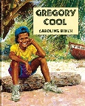  Contemporary Fiction  Gregory Cool – Caroline Binch  Letter/postcard  - Write a postcard from a holiday destination  - Write a letter in character from Gregory to his parents telling of his adventures in Tobago
Narrative | Contemporary Fiction  The Stone Age Boy- Satoshi Kitamura  Narrative  - Narrative about ending up going back in time. | Contemporary Fiction  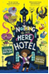  The Nothing to see Here Hotel- Steven Butler and Steven Lenton (Lit Shed +)  Setting description/Newspaper Report  - Setting description of the hotel  - Newspaper Report | 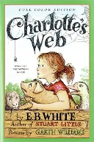  Classic Stories  Charlotte’s Web – E B White  Narrative/diary  - Write a setting description  - Write a diary entry from Fern at a key moment in the story  - Write own story set at the farm
Non-Narrative | Explanation Text  - Write explanation leaflet linked to damage being caused to the rainforest – deforestation etc | Newspaper report (links to the Stone Age topic)  - William Watts and the Skara Brae | Information Texts  - Write an information leaflet on the Roman Baths
Non-Narrative | Non-chronological report  - Where do rocks come from? Linked to geography unit. | Non-chronological report  - Linked to the topic of The Stone Age- Hillforts | Explanation  - Write an explanation linked the invasion of the Romans and why they were successful. (change to History Plan)
Poetry | Classic Poems  Please Mrs Butler Alan Ahlberg  - Write own ‘Mrs Butler’ style poem | Forms of Poetry - List Poems  - Write list poem linked to topic / text | Contemporary Poet  Valerie Bloom e.g. Fruits – A Caribbean Counting Poem  - Write and perform own poem based on poem read

Year 4 | WOW DAY SUGGESTIONS  1.Egyptian Day 2. Viking Day 3. Norman Day
 | AUTUMN  Cross Curriculum links: Living Things and their Habitats / Animals including Humans / All Around the World / Egyptians | SPRING  Cross Curriculum links: Electricity / Where is Sheffield? / Anglo Saxons and Viking Raids | SUMMER  Cross Curriculum links: States or Matter / Sound / The water Cycle / The Norman Conquest / Invasion
Narrative | 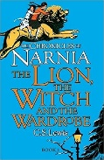  Classic Stories  The Lion the Witch and the Wardrobe CS Lewis  Character description/Narrative  - Write a character description e.g., Mr Tumnus / White Witch  - Write own ‘through the wardrobe’ adventure story | 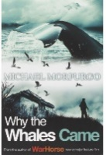  Classic Stories  Persuasive letter/Debate  Why the Whales Came – Michael Morpurgo  - Write a setting description  - Write a persuasive letter linked to The Birdman | 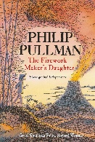  Contemporary Fiction  The Firework Maker’s Daughter Philip Pullman  Narrative/letter  - Write a description of Lila  - Write a letter in role as Lila  - Write adventure story based on the story read
Narrative | 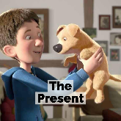  Film Unit – Literacy Shed Plus – The Present  Narrative  - Write a story based on the present. | 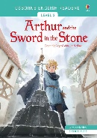  Traditional Tales - Legends  The Sword in the Stone  Recount  - Rewrite legend in own words from character’s perspective | 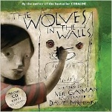  Contemporary Fiction  The Wolves in the Walls Neil Gaiman  Narrative  - Rewrite story with alternative creature in the walls
Narrative | 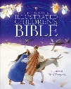  Playscripts  - Write playscript linked to RE e.g. Bible Story
Non-Narrative | Non- chronological report  - Write a non-chronological report on Egyptian Life | News report – journalistic  - Write news reports for an Anglo-Saxon Newspaper | Explanation  - Write topic or Science linked explanation text e.g., extreme weather
Non-Narrative | Instructions  - How to make a sandwich. | Explanation Texts  - write an explanation linked to Wallace and Gromit – Cracking Contraptions | Biography/Diary  - Write a biography on someone who inspires you.  - Write a diary as someone from the Bible stories – linked to RE
Poetry | Contemporary Poet  Michael Rosen e.g., Chocolate  - Write own food-related poem for class poetry book | Classic Poems  Overheard on a Saltmarsh Harold Monro  - Write own poem using alternative objects | Forms of Poetry – Haiku  - Write topic-linked haiku poems

Year 5 | WOW DAY SUGGESTIONS  1.Greek Day – food, dancing, clay pots, art 2.Victorian Day 3.Titanic Day – Art work, stories of characters etc
 | AUTUMN – Cross Curriculum links: Earth and Space / Marvellous Maps / The Greeks | SPRING Cross Curriculum links: Forces / Properties of Change / Energy and the Environment / Tudor/ Georgian/ Victorian | SUMMER Cross Curriculum links: Living things and their Habitats / Animals including Humans / Magnificent Mountains / The Titanic
Narrative | 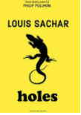  Contemporary Fiction  Holes by Louis Sachar  Non Chronological Report and description  - Write a report about the yellow spotted lizard  - Write a setting description of Camp Lake | 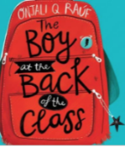  Contemporary Fiction  The Boy At the Back of The Class  Diary Entry/ Formal Letter/ Persuasion  - Write a diary entry of the First Day for Ahmet  - Write a formal letter to the Prime Minister  - Write a persuasive brochure to advertise London  There’s A Rang-Tan in my Bedroom | 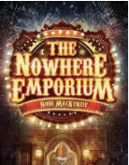  Nowhere Emporium by Ross Mckenzie  Biography/Narrative  - Write a biography of the main character  - Plan and write their wonder story.
Narrative |  | 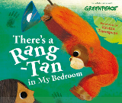  Discussion/Persuasive Letter  - Balanced Argument linked to Palm Oil  - Persuasive Letter | 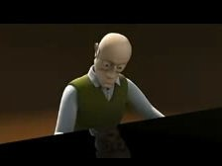  Film Narrative: The Piano Aiden Gibbons Biography/  Narrative  - Write a biography of the main character  - Write the narrative to accompany the film
Non-Narrative | 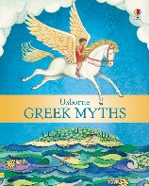  Traditional Tales – Greek Myths  Character Description/Greek myth  - Character Description – God or Goddess  - Write own Greek myth | Persuasion  Tourist Brochure  - London – Linked to Boy at the Back of the Class  Report: Linked to Geography unit- Why do Oceans matter? Field study findings | Journalistic  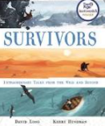  Recount/Diary Entry –  - Recount linked to a journey up Everest  - Diary Entry of Sir Edmund Hillary
Non-Narrative | Explanation/Instruction - Linked to Space Topic |  | Discussion / Argument  Write a balanced argument. Zoos: Prison or Paradise?
Poetry | Classic Poems- Tyger Tyger  Focus on poetic technique | Poetry Linked to Refugees/Further work Highway Man | Forms of Poetry  Narrative Poetry e.g. The Highway Man  Write a narrative of part / all of the poem

- Year 6 |  | Wow Day suggestions  1.World War Day 2. Carnival Day 3. Play Preparation
 | AUTUMN Cross Curriculum links: Living things and their Habitats / Animals including Humans / Wonderful Wales / WWII – Local History Study |  | SPRING Cross Curriculum links: Evolution and Inheritance / Amazing Americas / Anne Frank | SUMMER Cross Curriculum links: Light / Electricity / Trade and Economics / The Victorians Industrial and Railway Revolution
Narrative | 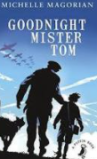  Classic Stories  Goodnight Mister Tom Michelle Magorian  Non chronological report/Informal Letter  - Character description - Willie  - Informal letter as Evacuee  - Narrative - dialogue |  | 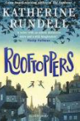  Rooftoppers – Katherine Rundell  Journalistic  - Newspaper report of  baby found in English Channel  Narrative/formal letter  - Setting description of rooftops  - Persuasive letter to authorities | 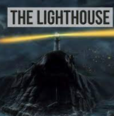  Film Narrative  The Lighthouse The Literacy Shed  Narrative story/Newspaper Report  - Narrative Story of the film  - Newspaper report of the crash
Narrative |  |  |  | 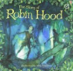  Traditional Tales – Legends Robin Hood  Explanation/Playscript  - Explanation Text- how to survive in the forest.  - Playscript related to key events
 | Shakespeare Study Macbeth  - ence  - Character description – three witches  - Diary entry – Macbeth  - Informal letter |  | 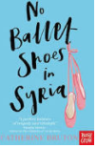  Contemporary Fiction No Ballet Shoes in Syria by Catherine Brunton  Narrative/diary entry/ persuasive letter  - Chapter ending  - Diary entry – Aya  - Persuasive advert to support refugees | 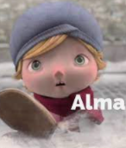  Alma – Film Narrative  Narrative  - 3rd person narrative  - Setting description
Non-Narrative | Non-Chronological report  Linked to History unit – Coventry and the Blitz  Recount – Journalistic  Linked to Suffragette movement – History ‘dive deeper day’ |  |  | Persuasion  Who should go on the bank note? Linked to History unit
Non-Narrative | Explanation  - The Heart (Science Link) |  | Discussion / Argument  - Balanced Argument – should the current Y6 SATS system continue?
Non-Narrative |  |  | Information Text  Charles Darwin information text (linked to science).
Poetry | Classic Poems - Dulce Decorum Est  War Poetry linked to Topic  Performance & Writing Outcome |  | Contemporary Poet  Benjamin Zephaniah e.g., The British  Performance & Writing Outcome | Forms of Poetry  Free Verse  Performance & Writing Outcome



